How To Write DirectMusic Producer DX7 Components

This document is confidential and contains highly sensitive information about Microsoft’s product development plans. This is a proprietary work owned by Microsoft Corporation, and is maintained as a trade secret. Unless provided for under an appropriate Non-Disclosure Agreement, this document may be shared only with authorized personnel at Microsoft. Discussion or transmission of this document (as well as any associated discussions about the contents of this document) to any unauthorized Microsoft personnel is specifically prohibited. Complying with all applicable copyright laws is the responsibility of the user. This document is Copyright © 1999 Microsoft Corporation. All rights Reserved. Without limiting the rights under copyright law, no part of this document may be reproduced, stored in or introduced into a retrieval system, or transmitted in any form or by any means (electronic, mechanical, photocopying, recording, or otherwise), or for any purpose, without the express written permission of Microsoft Corporation, One Microsoft Way, Redmond, WA 98052. Microsoft may have patents or pending patent applications, trademarks, copyrights, or other intellectual property rights covering subject matter in this document. Except as expressly provided in any written license from Microsoft, the furnishing of this document does not give you any license to these patents, trademarks, copyrights, or other intellectual property rights.

Table of Contents
Introduction to DirectMusic Producer 2
DirectMusic Producer Objects 5

Overview 5

Sample Work Session 10

DirectMusic Producer Module/Component Implementation Guidelines 18

Getting Started 18

Nodes and Editors 20

Plugging into Framework Functionality 25

System Registry 29

Exported Functions Implemented by DirectMusic Producer Modules 30

DllCanUnloadNow() 30

DllGetClassObject() 30

DllRegisterServer() 33

DllUnregisterServer() 35

Introduction to DirectMusic Producer
The DirectMusic Producer authoring environment is built around the concept of a visual workspace. Typically, the author uses Producer to prepare content on a project by project basis. For example, an author might be preparing a set of styles, chordmaps, downloadable sounds and segments for use in a game. Producer allows the author to bundle the above mentioned content in one DirectMusic Producer project workspace.
The Producer user interface is designed around a simple Framework. Like most productivity applications, it has a menu bar, toolbars, and status bar. In addition, the application incorporates a tree view to display all of the files in a given Project. This is called the Project Tree. The larger area to the right of the Project Tree is the Editor workspace. Double-clicking on a node in the Project Tree causes the Editor workspace to open a visual editor for the item.
The Project Tree manages assembling and selecting the files and objects within a project and the Editor workspace manages editing the files and objects.
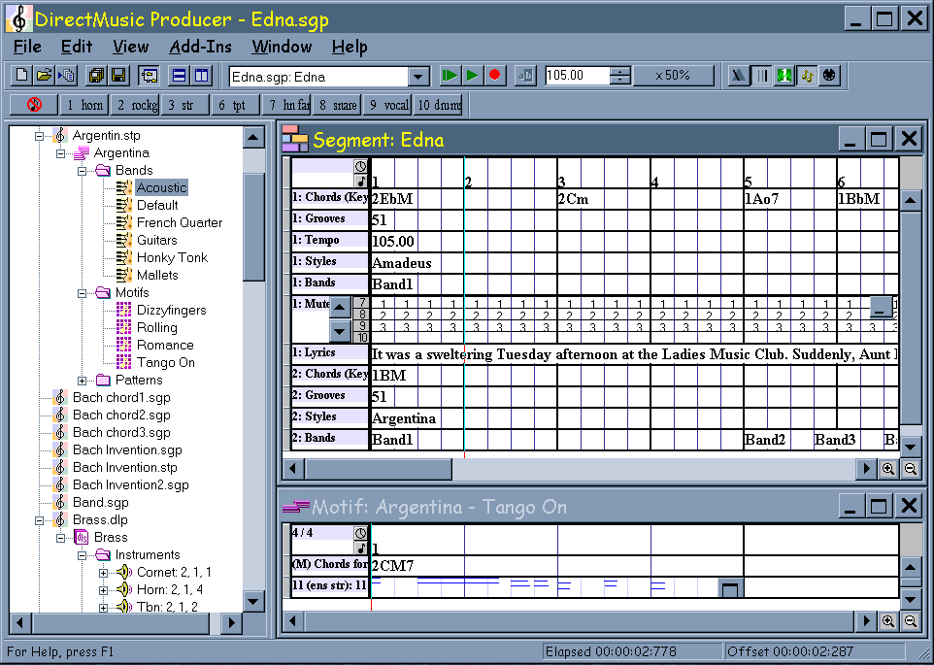
Project Tree
The Project Tree displays lists of files organized into one or more projects. Projects appear as left-most folders in the tree. When expanded, project folders list the files and other folders they contain. Every Producer project corresponds to a directory residing on disk and contains all of the files located in that entire directory tree. Adding and removing files from a project affects the contents of the directory tree because the contents of a Producer project mirrors the files on disk.
If desired, Explorer can be used to place files into the directory tree of a Producer project. Both Producer files and non-Producer files are displayed in the Project Tree. Double-clicking on a Producer file in the Project Tree will load the file into Producer. Double-clicking on a non-Producer file will open the application associated with its file extension.
After a Producer file has been double-clicked and loaded, its node will display with a plus sign to indicate that the tree can be expanded to reveal additional objects embedded within the file. For example, click on the plus sign next to a style and the style opens, exposing three folder items representing the style’s bands, motifs, and patterns. Click on the plus sign beside the band list node and another tier of items open below it, one for each band in the style. Double-clicking on one of the embedded nodes opens its editor.
Upon creating a new project, Producer places an empty project folder in the Project Tree. The user selects files to add to the project folder by either creating them or inserting them. Producer knows what document types are available for creation and loading and presents these as options from the New and Insert Files into Project commands in the File menu.
Each project file may be saved individually, or all files may be saved at once with the Save and Save Project commands in the File menu.
To remove a file from the project, the user selects it and hits the delete key.

Editor Workspace
The Editor workspace manages the actual editing space. Whenever a Project Tree node embedded within a file is double-clicked, the Editor workspace opens the appropriate editor for the item. For example, double-click on a pattern node within a style to open the pattern’s editor.
When an editor is activated, it in turn activates its menus and toolbars. When it loses focus, it automatically removes these from sight.
Each item has a unique editor. The editor for a style pattern is a very different piece of real estate from the editor that is used to edit the parameters of a downloadable instrument. In fact, the Framework knows nothing about how the editors work. Instead, it relies on each object type to provide its own editor. This is facilitated by the fact that Producer editors are all implemented in dynamically loaded code, called DirectMusic Producer Modules.

Producer Modules
The Producer Framework (DMUSProd.exe) provides two relatively simple sets of functionality:
- Manage the visual workspace environment.
- Extend the functionality of Producer by way of the module mechanism.

The vast majority of Producer’s functionality resides in Modules.
To encompass a broad range of functionality without imposing unnecessary limitations, the module mechanism is remarkably simple:
- Producer Modules are DLLs that load into Producer’s process space.
- Modules are comprised of one or more Producer Components.
- Producer keeps track of which Components to load via the Windows registry.
- Producer keeps a run time list of currently loaded Components.
- Each Component provides a set of zero or more COM interfaces representing specific sets of functionality. These interfaces can be addressed via the standard COM QueryInterface call. Some of these interfaces are known to many other Components, others are not.
- Producer provides a standard mechanism to access any interface from any Component, simply by requesting the interface by its GUID.

The Producer Framework intentionally relegates all media dependent functionality to Producer Components. Even hand shaking logic to allow multiple Components to use the same underlying music engine is implemented in a Component. This guarantees that the Producer Framework does not embrace any specific media mechanisms that could not be changed, extended, or replaced over time.
Producer Modules that manage the editing of media types, such as styles or DLS instruments, typically group all related Components together, rather than placing them in separate DLLs. Though not required, this can make internal management of tightly coupled objects easier. For example, the different objects within a DLS instrument really represent different chunk types within one file.
The remainder of this document describes the various tasks involved in building and integrating Producer Modules/Components into the Framework.

DirectMusic Producer Objects

Overview
Producer Framework Object
DMUSProd.exe manages the one and only Framework object. This object is created during application launch and exists throughout the entire Producer work session.
The Framework object is responsible for managing projects. It owns the Project Tree and implements IDMUSProdFramework so that Producer Components can plug into its functionality.

Producer Component Object
Producer Components are standard registered COM objects that extend the functionality of Producer by way of the module mechanism. These objects must implement the IDMUSProdComponent interface and understand the IDMUSProdFramework interface.
During Producer launch, the Framework object calls CoCreateInstance to obtain an IDMUSProdComponent interface pointer for each of the Producer Component CLSID's registered under:
[HKEY_LOCAL_MACHINE\Software\Microsoft\DMUSProducer\Components]
Producer Component objects exist until Producer shuts down.
After all registered Producer Components have been instantiated, the Framework turns around and calls each Component’s IDMUSProdComponent::Initialize method. This method receives a pointer to the Framework’s IDMUSProdFramework interface.
Components are not required to create any other “standard” Producer objects. The purpose of a Component may simply be to provide functionality to other Producer Components through custom interfaces. However, IDMUSProdComponent::Initialize will more than likely create one or more of the following Producer objects: Producer Menu object, Producer Toolbar object, Producer DocType object.

Producer Menu Object
A Producer Menu object defines the behavior of a single menu item. The object consists of a label, a context help string, a method to initialize its state, and a method to perform when selected. A Menu object must implement IDMUSProdMenu.
After creation, the object’s IDMUSProdMenu interface gets handed to the Framework via the Framework’s IDMUSProdFramework::AddMenuItem method. This method adds the menu item to the Framework’s Add-Ins menu. IDMUSProdFramework::AddMenuItem provides a way for a Component, that otherwise has no UI, to hook into the Framework. For example, a Component may want to place a menu item in the Framework's Add-Ins menu to provide a dialog that can be used to setup various options.
A Component determines the life span of a Menu object. However, a typical Component using Menu objects would create its Menu(s) and call IDMUSProdFramework::AddMenuItem from within in its IDMUSProdComponent::Initialize method. IDMUSProdComponent::CleanUp would then be used to call IDMUSProdFramework::RemoveMenuItem and delete the existing Menu object(s).

Producer Toolbar Object
Producer ToolBar objects are not tied to a specific editor. They reside in the Framework's toolbar space and are accessible to all Components via custom interfaces.
A Component determines the life span of a Toolbar object. However, a typical Component using Toolbar objects would create its Toolbar(s) and call IDMUSProdFramework::AddToolbar from within in its IDMUSProdComponent::Initialize method. IDMUSProdComponent::CleanUp would then be used to call IDMUSProdFramework::RemoveToolbar and delete the existing Menu object(s).

Producer DocType Object
A Producer Component can add additional document types to the Framework’s File/New, File/Insert Files into Project and File/Save dialogs. One DocType object must be created for each type of file that the Component wants to process. These objects must implement IDMUSProdDocType.
After creation, the object’s IDMUSProdDocType interface gets handed to the Framework via the Framework’s IDMUSProdFramework::AddDocType method. This method registers the DocType with Producer so that it will appear in the Framework’s File/New, File/Insert Files into Project and File/Save dialogs.
DocType objects must be created and registered with the Framework from within their Component’s IDMUSProdComponent::Initialize method. These objects exist throughout the entire Producer work session.
Producer Node Object
Producer Node objects represent a unit of data that can be edited and moved around within Producer. Originally, there was a one to one correspondence between Node objects and nodes in the Framework's Project Tree. However, this is no longer the case. A band in a segment's band track is an example of a node that does not display in the Project Tree. Node objects which display in the Project Tree must call IDMUSProdFramework::AddNode and IDMUSProdFramework::RemoveNode as they are created and deleted.
Node objects must implement IDMUSProdNode. Also, since Producer does not understand the relationships between nodes, every Node object must take on the responsibility of managing its own children. This means that every potential parent node must implement IDMUSProdNode::GetFirstChild and IDMUSProdNode::GetNextChild for the purpose of enumerating their children.
The following list contains interfaces that a Node may implement on an “as needed” basis: IDMUSProdPropPageObject, IDMUSProdSortNode, IDMUSProdReferenceNode, IDMUSProdNotifySink, IDMUSProdNodeDrop, IDMUSProdNotifyCPt, IDMUSProdTimelineCallback, IDMUSProdConductorTempo, IDMUSProdTransport, IDMUSProdSecondaryTransport, IpersistStream (required by DocRoot nodes).
There are seven (7) types of Node objects: Project Folder, Directory Folder, File, DocRoot, Folder, Data, and Reference.
Project Folder: Project Folders are the left-most nodes in the Project Tree. They represent an entire Producer project. Project Folders exist as folders in Explorer, and the Project Tree provides an Explorer-like view of their sub-directories and files. The Framework creates and manages Project Folder nodes.
Directory Folder: Project Folders may contain one or more Directory Folders, which are nothing more than sub-folders created for the purpose of organizing a project. Directory Folders exist as folders in Explorer, and the Project Tree provides an Explorer-like view of their sub-directories and files. The Framework creates and manages Directory Folder nodes.
File: There is a one-to-one correspondence between files in a project and File nodes. The Framework creates and manages File nodes.
DocRoot: A DocRoot node is the one and only child node of a File node. DocRoot nodes mark the place in the Project Tree hierarchy where responsibility shifts from the Framework to the Component. DocRoot nodes must also implement IPersistStream.
DocRoot nodes are important to the Framework's own internal representation of a file contained within a Producer Project for a couple of reasons: they provide the pathway to the actual data in a file, and they are used by the mechanism which sets up references for the purpose of linking files. IDMUSProdDocType::OnFileNew and IDMUSProdDocType::OnFileOpen hand the Framework a pointer to the DocRoot node (file) just loaded into the Project Tree. The Framework expects the DocRoot node to provide an IPersisStream interface so that it can handle file I/O appropriately.
Folder: A file in a Producer project may contain lists of objects. For example, a style file contains lists of bands, motifs, and patterns. These lists are placed in Folder nodes. Folder node objects do not contain file data. They simply represent lists of objects. A style file contains the following three (3) Folder nodes: 'Bands', Motifs', and 'Patterns'. Folder nodes exist as children under DocRoot nodes, other Folder nodes, or Data nodes.
Data: Data nodes represent chunks of data within a file. They may or may not have children. Data nodes exist as children under DocRoot nodes, Folder nodes, or other Data nodes.
Reference: Files that may be referenced from within other files must be able to create a set of DocRoot/Folder/Data nodes to represent themselves in the Project Tree as well as create Reference nodes that other files can use to set up file links. Reference nodes do not have children. They are simply nodes that point to other DocRoot nodes in the Project Tree. Reference nodes must implement both IDMUSProdNode and IDMUSProdReferenceNode.

Producer Editor Object

Producer Editor objects are standard registered COM objects that manage the real estate used to edit a specific node’s data. Normally the node will appear in the Project Tree but this is not necessary. A band in a segment's band track is an example of a node that does not display in the Project Tree. Editors are opened one of two ways: double-clicking their corresponding node in the Project Tree, or via the IDMUSProdFramework::OpenEditor method.

These objects must implement the IDMUSProdEditor, IOleObject, IViewObjectEx, IOleControl, IOleInPlaceObject and IOleInPlaceActiveObject interfaces.
The following methods are called when opening an editor for a node:
- IDMUSProdNode::GetEditorClsId – returns the CLSID of the node’s editor
- OleCreate – creates an embedded Editor object
- IDMUSProdEditor::AttachObjects – hands IDMUSProdNode to the Editor object
- IOleObject::DoVerb - displays Editor object (OLEIVERB_SHOW)
The Editor object is destroyed when the editor window closes.

Producer PropSheet Object
The Framework creates and manages the one and only Producer PropSheet object. This object is created during application launch and exists throughout the entire Producer work session. The PropSheet object is nothing more than a property sheet control. A Component uses the IDMUSProdPropSheet interface to interact with the Framework's PropSheet object.
In order to use Producer’s global property sheet control, Components must create a PropPageManager object for each set of pages that will be placed into the property sheet and a PropPageObject object for each object that will be displayed by those pages.

Producer PropPageManager Object
PropPageManager objects define a set of pages, or tabs, to be displayed in the Framework's global property sheet control. IDMUSProdPropSheet::SetPageManager sets the current PropPageManager and places its pages into the Framework's global property sheet. PropPageManager objects must implement the IDMUSProdPropPageManager interface.

Producer PropPageObject Object
A PropPageObject represents the data being displayed in the PropPageManager's pages. PropPageObjects must implement the IDMUSProdPropPageObject interface. Calls to IDMUSProdPropPageManager::SetObject set the PropPageManager's current object so that the same set of pages can be used to display data for different objects.

Sample Work Session
The following example shows a Producer work session in which three (3) files (MonsterCave.cdp, MonsterCave.stp, MonsterCave.tpp) are open:
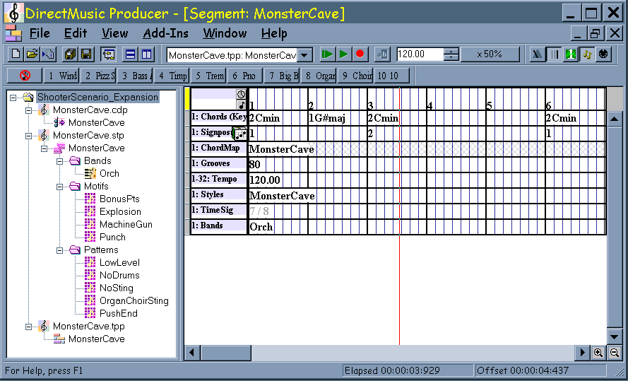
What “Producer” objects exist at this point in time? When were they created? The remainder of this section takes a look at the life cycle of Producer objects.

Application Launch
DMUSProd.exe creates the one and only Framework object. The Framework is the first Producer object created during application launch:
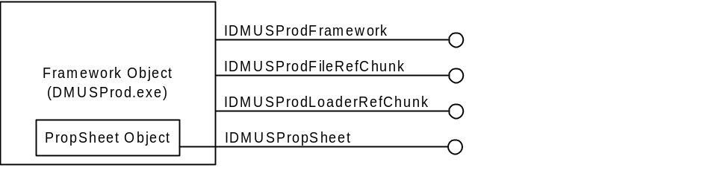
The Framework object exists throughout the entire work session and gets freed when DMUSProd.exe shuts down.
Once the Framework has been instantiated, DMUSProd.exe calls CoCreateInstance for each of the Producer Component CLSID’s registered under:
[HKEY_LOCAL_MACHINE\Software\Microsoft\DMUSProducer\Components]
CoCreateInstance results in the creation of Producer Component objects. Producer Components also exist throughout the entire work session. They are created, of course, by the DLLs that manage them. The following six (6) Components were created for the work session illustrated at the start of this section:
- The Conductor Component coordinates global access to the DirectMusic Engine for all Producer Components. Components wishing to use Conductor must call IDMUSProdFramework::FindComponent using the IDMUSProdFramework interface pointer handed to them via their IDMUSProdComponent::Initialize method.
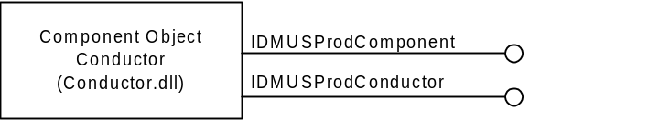
- The ChordMap Designer Component handles editing and file IO for ChordMap files.
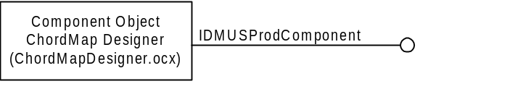
- The Band Editor Component manages bands. In the sample work session shown above, the Band Editor Component takes responsibility for loading, saving and editing bands in style files as well as bands in segment band tracks. It implements IDMUSProdRIFFExt so that the Style Designer Component and band track can be handed an IDMUSProdNode pointer to a band node after handing the Band Editor Component a stream containing a band.

- The DLS Designer Component is responsible for loading, saving, and editing DLS Collection files. It implements IDMUSProdPortNotify to receive notifications when the user changes the output port configuration.

- The Style Designer Component is responsible for loading, saving, and editing style files. It implements IDMUSProdPortNotify to receive notifications when the user changes the output port configuration.

- The Segment Designer Component manages segment files.
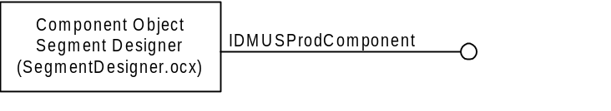

IDMUSProdFramework contains methods to enumerate the list of instantiated Component objects.
After the Framework loads all registered Producer Components, it turns around and calls each Component’s IDMUSProdComponent::Initialize method. In the work session shown above, the following DocType objects were created:
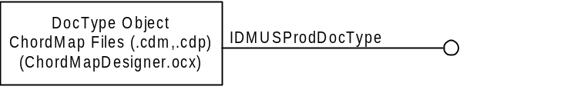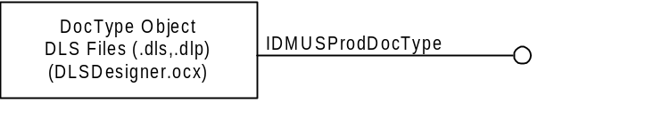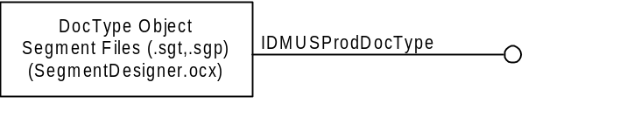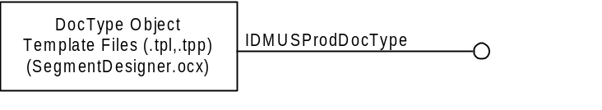
DocType objects exist throughout the entire Producer work session. After creation, DocType’s are handed to the Framework via the Framework’s IDMUSProdFramework::AddDocType method. IDMUSProdFramework contains methods to enumerate the list of the instantiated DocType objects.
In addition, the Conductor’s IDMUSProdComponent::Initialize method creates six (6) Toolbar objects: Transport Controls, Transport Options, Output Status, Secondary Segment, Synth Status, and Wave/MIDI Export. All six (6) toolbars exist throughout the Producer work session and support their own implementation of the IDMUSProdToolbar interface:
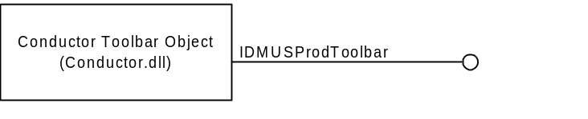
At this point during application launch we have one Framework object (containing a PropSheet object), six (6) Producer Component objects, six (6) DocType objects, and six (6) Toolbar objects. No other Producer objects are created until a project is either created or loaded. Our sample work session opens the ShooterScenario_Expansion project.

Project Open
First, the Framework creates a Project object to manage the project.
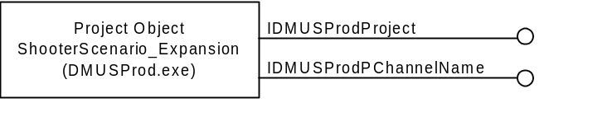
Since the code to open files resides in Component DLLs, the Framework takes on the responsilibty of routing File Open requests to the appropriate IDMUSProdDocType::OnFileOpen method. IDMUSProdDocType::DoesExtensionMatch helps the Framework locate the DocType object that manages files with a file extension equal to the file about to be opened. IDMUSProdDocType::OnFileOpen loads the file, creates corresponding Node object(s), and adds the Node(s) to the Project Tree.

Project Tree
The following illustration shows the Producer objects behind the nodes in the Project Tree that were created as a result of opening the ShooterScenario_Expansion project:
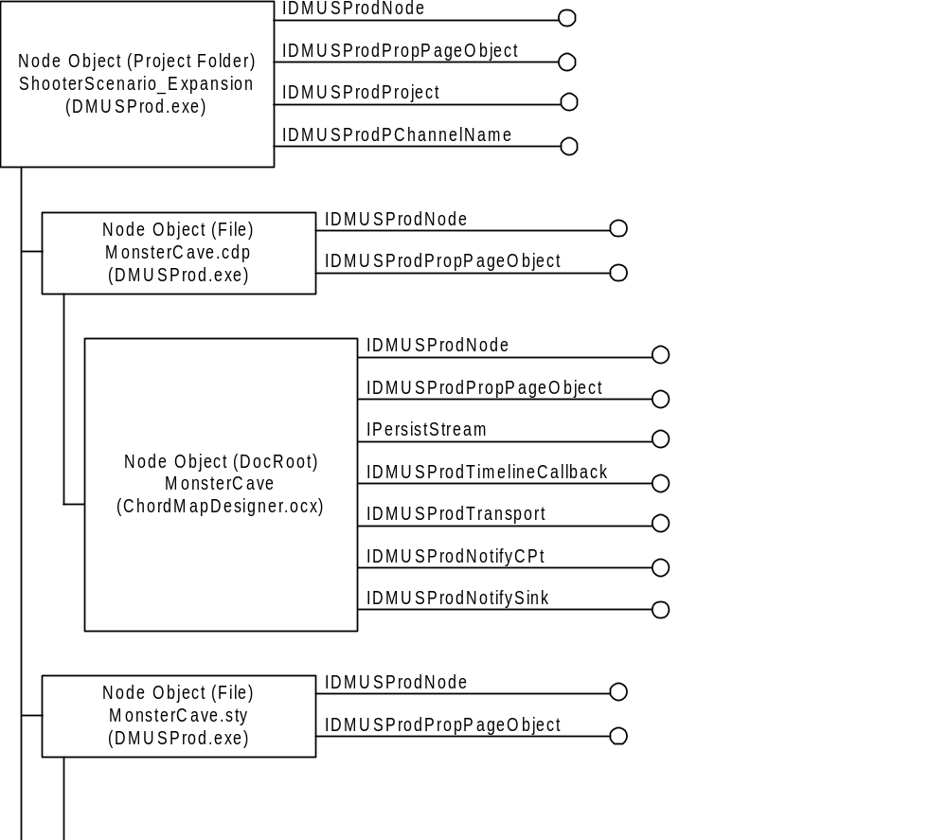

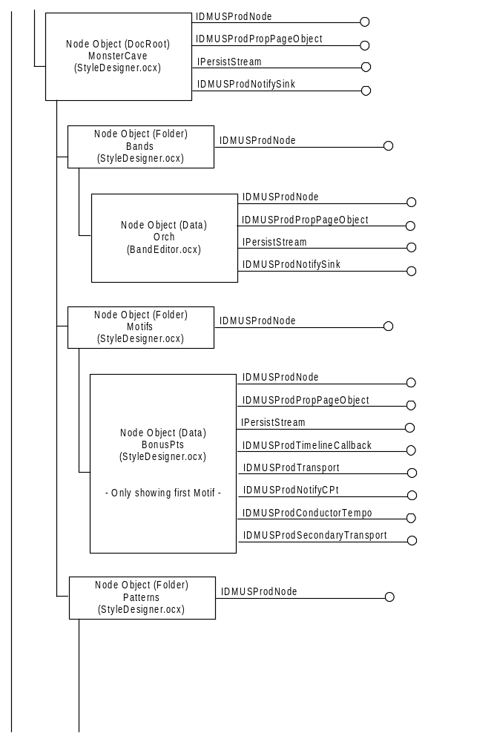
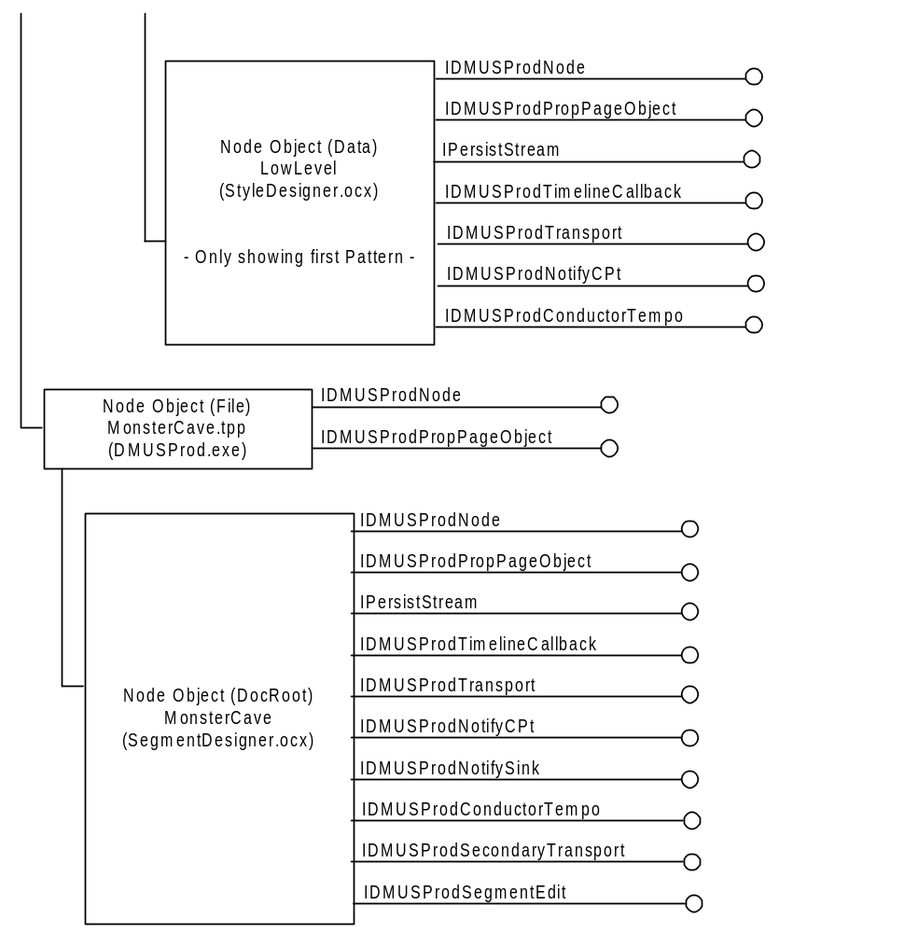
Editors
The life of an Editor object coincides with its appearance in an open editor window. When the editor window closes, the Editor object gets destroyed. Our sample work session shows an open editor for the MonsterCave template:
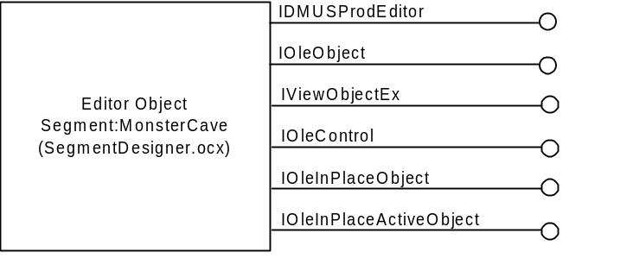

DirectMusic Producer Module/Component Implementation Guidelines

Getting Started
Bare Minimum
DirectMusic Producer Modules are DLLs that contain one or more Producer Components. Producer Components are standard COM objects created through CoCreateInstance that provide an IDMUSProdComponent interface.
A Producer Module (DLL) must implement DllCanUnloadNow, DllGetClassObject, DllRegisterServer, and DllUnregisterServer as specified in the section ‘Exported Functions Implemented by DirectMusic Producer Modules’. The DLL must also implement an IDMUSProdComponent interface for each of its Components as well as register a CLSID for each Component as specified within the section titled ‘DirectMusic Producer Module/Component Implementation Guidelines\System Registry’. This paragraph mentions all of the required “housekeeping” tasks that must be done in order to get a Component plugged into Producer.
‘Exported Functions Implemented by DirectMusic Producer Modules’ contains sample code that further explains the purpose and contents of the DllCanUnloadNow, DllGetClassObject, DllRegisterServer, and DllUnregisterServer methods.
Please refer to IDMUSPROD.HLP for more detailed information on implementing IDMUSProdComponent. As you will discover, a Component’s implementation of IDMUSProdComponent::Initialize is the place where the unique characteristics of a Component begin to take shape.

Some Producer Interfaces
IDMUSProdComponent is the only Producer interface whose implementation is mandatory.
If a Component works with files and wants the Framework to provide the UI to open and create new files, it should implement an IDMUSProdDocType interface for each type of file it supports. A Component’s IDMUSProdComponent::Initialize method should call IDMUSProdFramework::AddDocType to hand the Framework its IDMUSProdDocType interface(s).
A Component should implement the IDMUSProdMenu interface and call IDMUSProdFramework::AddMenuItem from within its IDMUSProdComponent::Initialize method if it wants to add a menu item to the Framework’s ‘Add-Ins’ menu. This interface provides a way for a Component, that otherwise has no UI, to hook into the Framework. For example, a Component may want to place a menu item in the Framework’s ‘Add-Ins’ menu to provide some sort of dialog that can be used to display performance statistics.
A Component should implement the IDMUSProdToolbar interface and call IDMUSProdFramework::AddToolbar from within its IDMUSProdComponent::Initialize method if it wants to add a toolbar to the Producer’s application toolbar space.
The IDMUSProdNode and IDMUSProdEditor interfaces should be implemented when a Component wants its objects to appear in the Framework’s Project Tree. IDMUSProdNode provides functionality for a node in the Project Tree and IDMUSProdEditor specifies behavior of the editor that is opened when a node is double-clicked.
The Producer interfaces mentioned above simply provide a starting point. They are the basic interfaces a Component should be aware of in order to plug into Producer. The complete Producer API reference is contained in IDMUSPROD.HLP. After opening IDMUSPROD.HLP select the “Index” tab, then type “interfaces” and hit <Enter>. A complete list of Producer interfaces will be displayed. In addition to “interfaces”, other helpful index topics are “objects”, “structures”, and “types”. Also, many of the method descriptions in the API reference contain sample code.

Custom Interfaces
When applicable, a Component may implement custom interfaces to provide additional functionality to other Components. For example, the Conductor Component exposes the IConductor interface to coordinate use of the DirectMusic Engine. A Component provides access to its custom interfaces through calls to its IDMUSProdComponent::QueryInterface method.

Nodes and Editors
VC++ 6.0 MFC ActiveX ControlWizard can be used to create Producer Modules containing Components that provide editors for the nodes they place into the Framework’s Project Tree. One control should be created for each type of editor supported in the DLL.
Since a control will function as a node’s editor, an IDMUSProdEditor interface must be implemented for each control. Also, the CLSID of the control is the CLSID that should be passed to the Framework via the IDMUSProdNode::GetEditorClsId method.
The control’s OnCreate method can create an in-place menu, an in-place toolbar, and a dialog. The dialog is created as a child window to the control and manages all editing of the underlying object:

// CBandCtrl Class
//
class CBandCtrl : public COleControl
{
friend class CBandDlg;

DECLARE_DYNCREATE(CBandCtrl)

// Constructor
public:
CBandCtrl();

// Attributes
public:
CBandDlg* m_pBandDlg;

private:
HWND m_hWndContainer;
HMENU m_hMenuInPlace;
HANDLE m_hKeyStatusBar;
CToolBar* m_pToolBar;
CBand* m_pBand;
CBandComponent* m_pComponent;
// Overrides
// ClassWizard generated virtual function overrides
//{{AFX_VIRTUAL(CBandCtrl)
public:
virtual void OnDraw(CDC* pdc, const CRect& rcBounds, const CRect& rcInvalid);
virtual void DoPropExchange(CPropExchange* pPX);
virtual void OnResetState();
virtual HMENU OnGetInPlaceMenu();
virtual void OnHideToolBars();
virtual void OnShowToolBars();
virtual BOOL PreTranslateMessage(MSG* pMsg);
//}}AFX_VIRTUAL

// Implementation
protected:
~CBandCtrl();

DECLARE_OLECREATE_EX(CBandCtrl) // Class factory and guid
DECLARE_OLETYPELIB(CBandCtrl) // GetTypeInfo
DECLARE_PROPPAGEIDS(CBandCtrl) // Property page IDs
DECLARE_OLECTLTYPE(CBandCtrl) // Type name and misc status

// Message maps
//{{AFX_MSG(CBandCtrl)
afx_msg int OnCreate(LPCREATESTRUCT lpCreateStruct);
afx_msg void AboutBox();
afx_msg void OnEditProperties();
afx_msg void OnDestroy();
afx_msg void OnSize(UINT nType, int cx, int cy);
afx_msg void OnEditUndo();
afx_msg void OnEditRedo();
afx_msg void OnUpdateEditUndo(CCmdUI* pCmdUI);
afx_msg void OnUpdateEditRedo(CCmdUI* pCmdUI);
afx_msg void OnSetFocus(CWnd* pOldWnd);
afx_msg void OnHelpFinder();
//}}AFX_MSG
DECLARE_MESSAGE_MAP()

// Dispatch maps
//{{AFX_DISPATCH(CBandCtrl)
// NOTE - ClassWizard will add and remove member functions here.
// DO NOT EDIT what you see in these blocks of generated code !
//}}AFX_DISPATCH
DECLARE_DISPATCH_MAP()

// Event maps
//{{AFX_EVENT(CBandCtrl)
// NOTE - ClassWizard will add and remove member functions here.
// DO NOT EDIT what you see in these blocks of generated code !
//}}AFX_EVENT
DECLARE_EVENT_MAP()

// Interface Maps
public:
// IOleInPlaceActiveObject
BEGIN_INTERFACE_PART(MyOleInPlaceActiveObject, IOleInPlaceActiveObject)
INIT_INTERFACE_PART(COleControl, MyOleInPlaceActiveObject)
STDMETHOD(GetWindow)(HWND*);
STDMETHOD(ContextSensitiveHelp)(BOOL);
STDMETHOD(TranslateAccelerator)(LPMSG);
STDMETHOD(OnFrameWindowActivate)(BOOL);
STDMETHOD(OnDocWindowActivate)(BOOL);
STDMETHOD(ResizeBorder)(LPCRECT, LPOLEINPLACEUIWINDOW, BOOL);
STDMETHOD(EnableModeless)(BOOL);
END_INTERFACE_PART(MyOleInPlaceActiveObject)

// IDMUSProdEditor functions
BEGIN_INTERFACE_PART(Editor, IDMUSProdEditor)
STDMETHOD(AttachObjects)(IDMUSProdNode*);
STDMETHOD(OnInitMenuFilePrint)(HMENU, UINT);
STDMETHOD(OnFilePrint)();
STDMETHOD(OnInitMenuFilePrintPreview)(HMENU, UINT);
STDMETHOD(OnFilePrintPreview)();
STDMETHOD(OnViewProperties)();
STDMETHOD(OnF1Help)();
END_INTERFACE_PART(Editor)

DECLARE_INTERFACE_MAP()

// Dispatch and event IDs
public:
enum {
//{{AFX_DISP_ID(CBandCtrl)
// NOTE: ClassWizard will add and remove enumeration elements here.
// DO NOT EDIT what you see in these blocks of generated code !
//}}AFX_DISP_ID
};
};

// OnCreate method
//
int CBandCtrl::OnCreate(LPCREATESTRUCT lpCreateStruct)
{
AFX_MANAGE_STATE(_afxModuleAddrThis);
if (COleControl::OnCreate(lpCreateStruct) == -1)
{
return -1;
}

if( m_pInPlaceFrame )
{
m_pInPlaceFrame->GetWindow( &m_hWndContainer );
}
else
{
// out of place active?
if( m_bOpen )
{
m_hWndContainer = GetParent()->GetSafeHwnd();
}
}

// Cut down on flicker when redrawing Band editor
ModifyStyle( 0, WS_CLIPCHILDREN, 0 );
CWnd* pWndParent = GetParent();
if( pWndParent )
{
pWndParent->ModifyStyle( 0, WS_CLIPCHILDREN, 0 );
}

// Load control's in-place menu
m_hMenuInPlace = ::LoadMenu( theApp.m_hInstance,
MAKEINTRESOURCE(IDR_BAND_EDITOR) );

// Create control's in-place toolbar
CWnd* pWndParent = CWnd::FromHandle( m_hWndContainer );
if( pWndParent )
{
m_pToolBar = new CToolBar;
m_pToolBar->Create( pWndParent );
m_pToolBar->LoadToolBar( IDR_BAND_EDITOR );
m_pToolBar->SetBarStyle( m_pToolBar->GetBarStyle() |
CBRS_SIZE_DYNAMIC );
m_pToolBar->SetOwner( this );
}

// Create control's dialog
m_pBandDlg = new CBandDlg();
if( m_pBandDlg == NULL )
{
return -1;
}

m_pBandDlg->m_pBandCtrl = this;
m_pBandDlg->Create( NULL, "WindowName", WS_CHILD | WS_VISIBLE,
CRect( 0, 0, 800, 400 ), this, 888, NULL );
m_pBandDlg->OnInitialUpdate();

return 0;
}

// OnSize method - Resize the dialog to fit the control
//
void CBandCtrl::OnSize(UINT nType, int cx, int cy)
{
AFX_MANAGE_STATE(_afxModuleAddrThis);
COleControl::OnSize(nType, cx, cy);

m_pBandDlg->MoveWindow( 0, 0, cx, cy );

}

// OnDestroy method
//
void CBandCtrl::OnDestroy()
{
AFX_MANAGE_STATE(_afxModuleAddrThis);
COleControl::OnDestroy();

if( m_hMenuInPlace )
{
::DestroyMenu( m_hMenuInPlace );
m_hMenuInPlace = NULL;
}

if( m_pToolBar )
{
delete m_pToolBar;
m_pToolBar = NULL;
}
}

The control’s OnGetInPlaceMenu method returns a handle to the menu that will be merged into the container's existing menu:

// OnGetInPlaceMenu method
//
HMENU CBandCtrl::OnGetInPlaceMenu()
{
return m_hMenuInPlace;
}

The control’s OnShowToolBars and OnHideToolBars methods prepare the editing environment by plugging into the Framework’s status bar and displaying/removing the control’s in-place toolbar:

#define TOOLBAR_HEIGHT 29

// OnShowToolBars method
//
void CBandCtrl::OnShowToolBars()
{
AFX_MANAGE_STATE(_afxModuleAddrThis);
BORDERWIDTHS border;
CRect rectBorder;

if( m_pInPlaceFrame == NULL )
{
return;
}

m_pInPlaceFrame->SetActiveObject(&m_xMyOleInPlaceActiveObject, NULL);

if( m_pInPlaceDoc != NULL )
{
m_pInPlaceDoc->SetActiveObject(&m_xMyOleInPlaceActiveObject, NULL);
}

// Create status bar panes if they don't already exist
if( m_hKeyStatusBar == NULL )
{
m_pBand->m_pComponent->m_pIFramework->SetNbrStatusBarPanes(
1, SBLS_EDITOR, &m_hKeyStatusBar );
m_pBand->m_pComponent->m_pIFramework->SetStatusBarPaneInfo(
m_hKeyStatusBar, 0, SBS_SUNKEN, 15 );
}
// Show the controls’ in-place toolbar
if( m_pToolBar )
{
if( SUCCEEDED ( m_pInPlaceFrame->GetBorder(&rectBorder) ) )
{
border.top = TOOLBAR_HEIGHT;
border.left = 0;
border.right = 0;
border.bottom = 0;

if( SUCCEEDED (m_pInPlaceFrame->RequestBorderSpace(&border)) )
{
m_pInPlaceFrame->SetBorderSpace( &border );

m_pToolBar->MoveWindow( rectBorder.left,
rectBorder.top,
rectBorder.Width(),
TOOLBAR_HEIGHT );
m_pToolBar->ShowWindow( SW_SHOWNORMAL );
return;
}
}
}

m_pInPlaceFrame->SetBorderSpace( NULL );

}

// OnHideToolBars method
//
void CBandCtrl::OnHideToolBars()
{
AFX_MANAGE_STATE(_afxModuleAddrThis);
ASSERT( m_pBand != NULL );
ASSERT( m_pBand->m_pComponent != NULL );

// Restore the Framework’s status bar
m_pBand->m_pComponent->m_pIFramework->RestoreStatusBar(
m_hKeyStatusBar );
m_hKeyStatusBar = NULL;

// Hide the control’s in-place toolbar
if( m_pToolBar )
{
BORDERWIDTHS border;

border.top = 0;
border.left = 0;
border.right = 0;
border.bottom = 0;

if( SUCCEEDED ( m_pInPlaceFrame->RequestBorderSpace(&border) ) )
{
m_pInPlaceFrame->SetBorderSpace( &border );
m_pToolBar->ShowWindow( SW_HIDE );
return;
}
}

m_pInPlaceFrame->SetBorderSpace( NULL );
}

Plugging into Framework Functionality

Clipboard
Use of the clipboard is handled through the following OLE API’s: OleSetClipboard, OleGetClipboard, OleFlushClipboard, and OleIsCurrentClipboard. These API’s use the OLE interface IDataObject to transfer data.

Drag-and-Drop
The Project Tree and Producer editors accept dropped objects from themselves and each other through the following OLE interfaces: IDropSource, IDropTarget and IDataObject.
Components should implement IDropSource and IDropTarget for each of their open editors and IDataObject for each object that is associated with a node in the Project Tree. The node’s IDataObject will also be associated with the node’s open editor since they represent the same data. IDataObject will be used for both drag-and-drop and clipboard operations.
Producer editors should call RegisterDragDrop() when they open and RevokeDragDrop() when they close. They will then call DoDragDrop() when they detect the user has begun a drag-and-drop operation.
The Project Tree will call IDMUSProdNode::CreateDataObject to ask a node for its IDataObject when it detects that the user has initiated a drag-and-drop operation for a specific node.
Dropping a Producer object into the Project Tree will accomplish tasks such as duplicating a style, duplicating a band within a style, placing a clone of a band in another style, moving a band from style A to style B, and extracting a band from a style so that it can be saved as a separate file.
Dropping a Producer object into an editor simply inserts the dropped object into the editor’s object. For example, one could drop a band on a style editor to insert that band into the style. One could not, for example, drop a band on either a band editor or a pattern editor.

Persistence
Data moves throughout Producer via implementations of IPersistStream. File IO, drag-drop, and clipboard operations all use IPersistStream to manage the flow of data. DocRoot nodes are required to implement IPersistStream so that the
Framework can take on the responsibility of file management and initiate file loading and saving.
Producer does some interesting things with streams. Streams must always be created through the Framework’s IDMUSProdFramework::AllocFileStream or IDMUSProdFramework::AllocMemoryStream methods. Why? Because streams returned by these methods also implement the IDMUSProdPersistInfo interface and IDMUSProdPersistInfo provides additional information about the stream that must be communicated to an object before a save takes place.
For example, Producer creates both runtime and design versions of its files. Runtime files are compact and are the files distributed to end-users. Design files are bulkier. They are meant for use within Producer because they store additional chunks of data containing UI state information. IPersistStream::Save needs to know whether it is supposed to save a runtime version or a design version of itself. IDMUSProdPersistInfo provides this kind of additional information about the stream.
A node’s IPersistStream::Save method must call IStream::QueryInterface to obtain the IDMUSProdPersistInfo interface associated with the stream into which it is supposed to save data. IDMUSProdPersistInfo:: GetStreamInfo returns information that must be used to determine the format/type of information the node is being asked to save into the stream. More information can be found under IDMUSProdPersistInfo in IDMUSPROD.HLP.

Progress Bar
The IDMUSProdFramework interface provides access to the Framework’s progress bar through the following five (5) methods: StartProgressBar, SetProgressBarPos, SetProgressBarStep, StepProgressBar, and EndProgressBar.
StartProgressBar should be called just before a lengthy process is about to begin and EndProgressBar should be called immediately after the process has completed.
SetProgressBarPos can be called during the lengthy process to update the status of the progress bar. Alternatively, SetProgressBarStep and StepProgressBar can be used to update the position of the progress bar.
The following code excerpt shows how to use the Framework’s progress bar:
IDMUSProdFramework* pIFramework;
HANDLE hKey;

CString strPrompt = _T( "Preparing information" );
BSTR bstrPrompt = strPrompt.AllocSysString();

pIFramework->StartProgressBar( 0, 50, bstrPrompt, &hKey );
for( int i = 0 ; i < 50 ; i++ )
{
Sleep( 50 ); // measurable processing would occur here
pIFramework->SetProgressBarPos( hKey, i );
}
pIFramework->EndProgressBar( hKey );

Right-Click Context Menu
A Component should provide a context menu for each node it places in the Project Tree. The Framework uses the following IDMUSProdNode methods to display and track this menu whenever a node is right-clicked: GetRightClickMenuId, OnRightClickMenuInit, and OnRightClickMenuSelect.
A DocRoot node’s context menu should be patterned after the following menu:
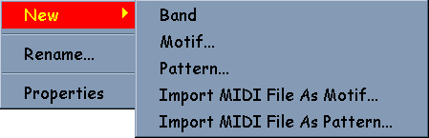
The ‘New’ sub-menu will vary for each DocRoot node (i.e. Menu above shows the items that can be inserted into a style).
The context menu for other nodes should be patterned as follows:
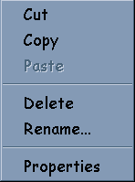
Context menus may have more/less menu items depending on the functionality of their corresponding node. Items should remain ghosted when not applicable.
Status Bar
The IDMUSProdFramework interface provides access to the Framework’s status bar through the following 4 methods: SetNbrStatusBarPanes, SetStatusBarPaneInfo, SetStatusBarPaneText and RestoreStatusBar.
If desired, a Producer editor may customize the Framework’s status bar to contain editor specific information. SetNbrStatusBarPanes places one or more panes on the right side of the Framework’s status bar. The Framework continues to use the left side of the status bar for the progress bar and to display help text.
One possible place to call SetNbrStatusBarPanes is during in-place activation, when the editor’s toolbar is being displayed. To do this, MFC OLE controls would call SetNbrStatusBarPanes from within the control’s OnShowToolBars method. RestoreStatusBar removes editor specific panes from the Framework’s status bar and would be called from an MFC OLE control’s OnHideToolBars method.
SetStatusBarPaneInfo and SetStatusBarPaneText can be used to set the ID, style, width and text of each pane.
The following example places two (2) panes on the right side of the Framework’s status bar:
IDMUSProdFramework* pIFramework;
HANDLE hKey;

pIFramework->SetNbrStatusBarPanes( 2, SBLS_EDITOR, &hKey );

BSTR bstrName = m_pStyle->m_strCategoryName.AllocSysString();
pIFramework->SetStatusBarPaneInfo( hKey, 0, SBS_NOBORDERS, 16 );
pIFramework->SetStatusBarPaneText( hKey, 0, bstrName, TRUE );

bstrName = m_pStyle->m_strName.AllocSysString();
pIFramework->SetStatusBarPaneInfo( hKey, 1, SBS_SUNKEN, 16 );
pIFramework->SetStatusBarPaneText( hKey, 1, bstrName, TRUE );

The IOleInPlaceFrame interface contains a method that places text in a container’s status bar. This method, IOleInPlaceFrame::SetStatusText, should be used to place text on the left side of the Framework’s status bar. MFC OLE controls can find a pointer to this interface in the COleControl::m_pInPlaceFrame member variable. The following line of code would place the text in bstrMsg on the left side of the Framework’s status bar:
m_pInPlaceFrame->SetStatusText( bstrMsg );

System Registry
DLLs are required to self-register their components. MFC automatically takes care of OLE specific entries (i.e. CBandCtrl::CBandCtrlFactory::UpdateRegistry), but the DLL must register/unregister the Producer specific entries for each control in DllRegisterServer and DllUnregisterServer respectively.
Each component must register itself as follows under
[HKEY_LOCAL_MACHINE\SOFTWARE\Microsoft\DMUSProducer\Components]:

REGEDIT4

[HKEY_LOCAL_MACHINE\SOFTWARE\Microsoft\]
[HKEY_LOCAL_MACHINE\SOFTWARE\Microsoft\DMUSProducer]
[HKEY_LOCAL_MACHINE\SOFTWARE\Microsoft\DMUSProducer\Components]

[HKEY_LOCAL_MACHINE\SOFTWARE\Microsoft\DMUSProducer\Components\
{44207724-487B-11D0-89AC-00A0C9054129}]
@="Band Editor"
"Skip"=dword:00000000
Skip: A non-zero value directs the Framework to bypass the Component during the Framework’s launch. ‘Skip’ may be helpful during testing when debugging multiple Components.
In addition, each component must register itself under [HKEY_CLASSES_ROOT\CLSID]:

REGEDIT4

[HKEY_CLASSES_ROOT\CLSID\
{44207724-487B-11D0-89AC-00A0C9054129}]
@="Band Editor"

[HKEY_CLASSES_ROOT\CLSID\
{44207721-487B-11D0-89AC-00A0C9054129}\InProcServer32]
@="C:\\_SRC\\PRODUCER\\BANDEDITOR\\DEBUG\\BANDEDITOR.OCX"
"ThreadingModel"="Apartment"

Exported Functions Implemented by Producer Modules

DllCanUnloadNow()
DllCanUnloadNow must be implemented and exported from DLLs that are dynamically loaded through a call to the CoGetClassObject function. The Producer Framework uses CoGetClassObject to load Producer Components.
OLE calls DllCanUnloadNow through a call to the CoFreeUnusedLibraries function. DllCanUnloadNow determines whether the DLL from which it is exported is still in use. A DLL is no longer in use when it is not managing any existing objects (the reference count on all of its objects is 0). When DllCanUnloadNow returns S_OK, CoFreeUnusedLibraries safely frees the DLL.

Sample Code

LONG g_lLock = 0; // g_lLock indicates whether or not any object in
// the DLL is still in use.
// g_lLock is incremented in every AddRef()
// in the DLL and decremented in every
// Release() in the DLL.

///////////////////////////////////////////////////////////////////////////// DllCanUnloadNow

STDAPI DllCanUnloadNow()
{
return ( g_lLock == 0 ) ? S_OK : S_FALSE;
}

///////////////////////////////////////////////////////////////////////////// DllCanUnloadNow – when using MFC

STDAPI DllCanUnloadNow()
{
AFX_MANAGE_STATE(_afxModuleAddrThis);

return AfxDllCanUnloadNow();
}

DllGetClassObject()
DllGetClassObject is called from within the CoGetClassObject function when CoGetClassObject finds that the class object to be loaded is in a DLL. The Producer Framework uses CoGetClassObject to load Producer Components.
DllGetClassObject creates the class object and calls its QueryInterface method to retrieve a pointer to the interface requested in riid.

Sample Code

///////////////////////////////////////////////////////////////////////////// CClassFactory
// Class factory object for creating any object implemented by this DLL.

typedef HRESULT (__stdcall CreateInstanceFunc) (IUnknown *punkOuter,
REFIID riid, void **ppv);

class CClassFactory : public IClassFactory
{
// IUnknown implementation
protected:
ULONG m_dwRef;
public:
STDMETHODIMP QueryInterface(REFIID riid, LPVOID *ppv)
{
if (IsEqualIID(riid, IID_IUnknown) ||
IsEqualIID(riid, IID_IClassFactory))
{
*ppv = (LPVOID) this;
AddRef();
return NOERROR;
}
else
{
*ppv = NULL;
return E_NOINTERFACE;
}
}
STDMETHODIMP_(ULONG) AddRef()
{
return ++m_dwRef;
}
STDMETHODIMP_(ULONG) Release()
{
if (--m_dwRef == 0L)
{
delete this;
return 0;
}
else
return m_dwRef;
}

// IClassFactory implementation
protected:
CreateInstanceFunc *m_pfunc; // function that creates object
public:
STDMETHODIMP CreateInstance(LPUNKNOWN punkOuter, REFIID riid,
LPVOID *ppv)
{
return (*m_pfunc)(punkOuter, riid, ppv);
}
STDMETHODIMP LockServer(BOOL fLock)
{
if( fLock )
{
AfxOleLockApp();
}
else
{
AfxOleUnlockApp();
}

return NOERROR;
}

// Construction
CClassFactory(CreateInstanceFunc *pfunc) : m_pfunc(pfunc)
{
m_dwRef = 0;
}
};

///////////////////////////////////////////////////////////////////////////// CREATE_INSTANCE macro

#define CREATE_INSTANCE( cls ) STDAPI \
cls##_CreateInstance( LPUNKNOWN /*punkOuter*/, REFIID riid, LPVOID *ppv ) \
{ \
HRESULT hrReturn; \
cls* pthis; \
pthis = new cls; \
if( pthis == NULL ) \
{ \
return E_OUTOFMEMORY; \
} \
hrReturn = pthis->QueryInterface( riid, ppv ); \
if( FAILED( hrReturn ) ) \
{ \
delete pthis; \
*ppv = NULL; \
} \
return hrReturn; \
}

CREATE_INSTANCE( CBandComponent )

///////////////////////////////////////////////////////////////////////////// DllGetClassObject

STDAPI DllGetClassObject( REFCLSID rclsid, REFIID riid, LPVOID *ppv )
{
AFX_MANAGE_STATE(_afxModuleAddrThis);

*ppv = NULL;

if( !IsEqualIID(riid, IID_IUnknown)
&& !IsEqualIID(riid, IID_IClassFactory) )
{
return E_NOINTERFACE;
}

// point <pfunc> to a function that can create a new object instance
CreateInstanceFunc *pfunc;

if( IsEqualCLSID(rclsid, CLSID_CBandComponent) )
{
pfunc = CBandComponent_CreateInstance;
if( ( *ppv = static_cast<void*>( static_cast<IClassFactory *>
( new CClassFactory( pfunc ) ) ) ) == NULL )
{
return E_OUTOFMEMORY;
}
static_cast<IUnknown*>( *ppv )->AddRef();
}

// Objects created by VC++ 6.0 MFC ActiveX ControlWizard
// must call AfxDllGetClassObject()

else if( IsEqualCLSID(rclsid, CLSID_CBandEditor) )
{
AFX_MANAGE_STATE( AfxGetStaticModuleState() );
AfxDllGetClassObject( rclsid, riid, ppv );
if( *ppv == NULL )
{
return E_OUTOFMEMORY;
}
}
else
{
return E_FAIL;
}

return NOERROR;
}

DllRegisterServer()

This exported function creates the registry entries for all of the Components supported in the DLL. It is invoked by regsvr32.exe. For example, typing ‘Run regsvr32 C:\Producer\StyleDesigner.ocx’ would result in DllRegisterServer being called to create the necessary registry entries for all of the Producer Components in StyleDesigner.ocx.
‘DirectMusic Producer Module/Component Implementation Guidelines\System Registry’ lists the Producer specific registry entries that DllRegisterServer must create for each Component.

Sample Code

///////////////////////////////////////////////////////////////////////////// SetRegString - Writes a string to system registry

static BOOL SetRegString( HKEY hKey, LPCTSTR lpSubKey, LPTSTR lpValueName, LPCTSTR lpszString )
{
HKEY hKeyOpen;
DWORD dwCbData;
LONG lResult;
DWORD dwDisposition;
BOOL fSuccess = FALSE;

lResult = RegCreateKeyEx( hKey, lpSubKey, 0, 0,
REG_OPTION_NON_VOLATILE, KEY_ALL_ACCESS, NULL,
&hKeyOpen, &dwDisposition );
if( lResult == ERROR_SUCCESS )
{
dwCbData = _tcslen(lpszString)+1;

lResult = RegSetValueEx( hKeyOpen, lpValueName, 0, REG_SZ,
(LPBYTE)lpszString, dwCbData);
if( lResult == ERROR_SUCCESS )
{
fSuccess = TRUE;
}
RegCloseKey( hKeyOpen );
}

return fSuccess;
}

///////////////////////////////////////////////////////////////////////////// SetRegDWORD - Writes a DWORD to system registry

static BOOL SetRegDWORD( HKEY hKey, LPCTSTR lpSubKey,
LPTSTR lpValueName, LPDWORD lpDWORD, BOOL fOverWrite )
{
HKEY hKeyOpen;
DWORD dwCbData;
LONG lResult;
DWORD dwDisposition;
DWORD dwType;
BOOL fSuccess = FALSE;

lResult = RegCreateKeyEx( hKey, lpSubKey, 0, 0,
REG_OPTION_NON_VOLATILE, KEY_ALL_ACCESS, NULL,
&hKeyOpen, &dwDisposition );
if( lResult == ERROR_SUCCESS )
{
lResult = ::RegQueryValueEx( hKeyOpen, lpValueName, NULL,
&dwType, NULL, NULL );

if( (lResult != ERROR_SUCCESS)
|| (dwType != REG_DWORD)
|| (fOverWrite == TRUE) )
{
dwCbData = sizeof( DWORD );
lResult = RegSetValueEx( hKeyOpen, lpValueName, 0,
REG_DWORD, (LPBYTE)lpDWORD, dwCbData);
if( lResult == ERROR_SUCCESS )
{
fSuccess = TRUE;
}
}
else
{
fSuccess = TRUE;
}
RegCloseKey( hKeyOpen );
}

return fSuccess;
}

///////////////////////////////////////////////////////////////////////////// RegisterComponents - Adds entries to system registry for Producer
// Components

static BOOL RegisterComponents( void )
{
LPOLESTR psz;
TCHAR szRegPath[MAX_BUFFER];
TCHAR szOCXPath[MAX_BUFFER];
TCHAR szOCXLongPath[MAX_BUFFER];
TCHAR szGuid[MID_BUFFER];
CString strName;
DWORD dwSkip = 0;

GetModuleFileName( theApp.m_hInstance, szOCXLongPath, MAX_BUFFER );
// This needs to be the short name, since the AfxRegister... functions
// use the short name.
GetShortPathName( szOCXLongPath, szOCXPath, MAX_BUFFER);

// Register Band Editor Component
if( SUCCEEDED( StringFromIID(CLSID_BandComponent, &psz) ) )
{
WideCharToMultiByte( CP_ACP, 0, psz, -1, szGuid, sizeof(szGuid),
NULL, NULL );
CoTaskMemFree( psz );
strName.LoadString( IDS_BAND_COMPONENT_NAME );

_tcscpy( szRegPath, _T("CLSID") );
_tcscat( szRegPath, _T("\\") );
_tcscat( szRegPath, szGuid );
if(!(SetRegString(HKEY_CLASSES_ROOT, szRegPath, _T(""), strName)))
{
return FALSE;
}

_tcscat( szRegPath, _T("\\") );
_tcscat( szRegPath, _T("InProcServer32") );
if(!(SetRegString(HKEY_CLASSES_ROOT, szRegPath,
_T(""), szOCXPath))
|| !(SetRegString(HKEY_CLASSES_ROOT, szRegPath,
_T("ThreadingModel"),
_T("Apartment"))) )
{
return FALSE;
}

_tcscpy( szRegPath,
_T("Software\\Microsoft\\DMUSProducer\\Components\\") );
_tcscat( szRegPath, szGuid );
if(!(SetRegString(HKEY_LOCAL_MACHINE, szRegPath, _T(""), strName))
|| !(SetRegDWORD(HKEY_LOCAL_MACHINE, szRegPath, _T("Skip"),
&dwSkip, FALSE)) )
{
return FALSE;
}
}
else
{
return FALSE;
}

return TRUE;
}

///////////////////////////////////////////////////////////////////////////// DllRegisterServer - Adds entries to the system registry

STDAPI DllRegisterServer(void)
{
AFX_MANAGE_STATE(_afxModuleAddrThis);

if( !AfxOleRegisterTypeLib(AfxGetInstanceHandle(), _tlid) )
{
return ResultFromScode(SELFREG_E_TYPELIB);
}
if( !COleObjectFactoryEx::UpdateRegistryAll(TRUE) )
{
return ResultFromScode(SELFREG_E_CLASS);
}
if( !RegisterComponents() )
{
return ResultFromScode(SELFREG_E_FIRST+2);
}

return NOERROR;
}

DllUnregisterServer()
This exported function removes all registry entries created by DllRegisterServer. It is invoked by regsvr32.exe. For example, typing ‘Run regsvr32 /u C:\Producer\StyleDesigner.ocx’ would result in DllUnregisterServer being called to remove all registry entries created by the Style Designer DLL’s DllRegisterServer function.

Sample Code

/////////////////////////////////////////////////////////////////////////////
// UnregisterComponents - Removes entries from the system registry for
// Producer Components

static BOOL UnregisterComponents( void )
{
LPOLESTR psz;
TCHAR szRegPath[MAX_BUFFER];
TCHAR szGuid[MID_BUFFER];

if( SUCCEEDED( StringFromIID(CLSID_BandComponent, &psz) ) )
{
WideCharToMultiByte( CP_ACP, 0, psz, -1, szGuid, sizeof(szGuid),
NULL, NULL );
CoTaskMemFree( psz );

_tcscpy( szRegPath, _T("CLSID\\") );
_tcscat( szRegPath, szGuid );
_tcscat( szRegPath, _T("\\") );
_tcscat( szRegPath, _T("InProcServer32") );

// First delete the subkey
if( RegDeleteKey(HKEY_CLASSES_ROOT, szRegPath) != ERROR_SUCCESS )
{
return FALSE;
}

_tcscpy( szRegPath, _T("CLSID\\") );
_tcscat( szRegPath, szGuid );

// Then the main key
if( RegDeleteKey(HKEY_CLASSES_ROOT, szRegPath) != ERROR_SUCCESS )
{
return FALSE;
}

_tcscpy( szRegPath,
_T("Software\\Microsoft\\DMUSProducer\\Components\\") );
_tcscat( szRegPath, szGuid );
if( RegDeleteKey(HKEY_LOCAL_MACHINE, szRegPath) != ERROR_SUCCESS )
{
return FALSE;
}
}
else
{
return FALSE;
}

return TRUE;
}

/////////////////////////////////////////////////////////////////////////////
// DllUnregisterServer - Removes entries from the system registry

STDAPI DllUnregisterServer(void)
{
AFX_MANAGE_STATE(_afxModuleAddrThis);

if (!AfxOleUnregisterTypeLib(_tlid, _wVerMajor, _wVerMinor))
return ResultFromScode(SELFREG_E_TYPELIB);

if (!COleObjectFactoryEx::UpdateRegistryAll(FALSE))
return ResultFromScode(SELFREG_E_CLASS);

if( !UnregisterComponents() )
{
return ResultFromScode(SELFREG_E_FIRST+2);
}

return NOERROR;
}

